**Evolution Of Computer**

The invention of electricity led to the rapid development of computers in the twentieth century.

**The Electronic Computers**

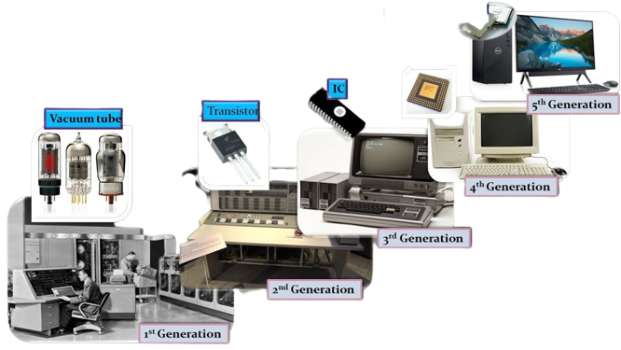

|  |  |
| --- | --- |
| **Generation** | **Period** |
| 1st | 1942-1955 |
| 2nd | 1955-1964 |
| 3rd | 1965-1975 |
| 4th | 1975 to the present |
| 5th | Future |

**The first-generation computers (1942-1955)**

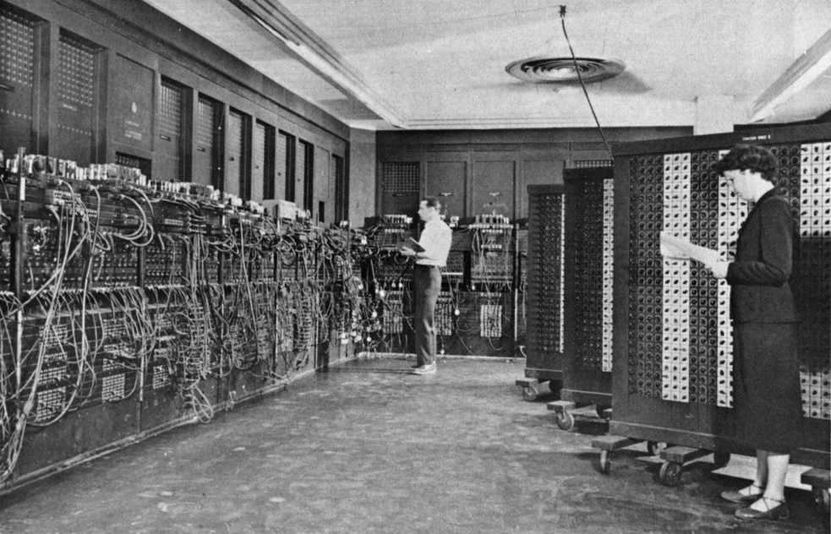

The computers were developed from 1942 to 1955 called the first-generation computer.

1st generation computers used **Vacuum tubes**

Vacuum tubes consist of a glass bulb and wire. The wires are used to carry data in the form of electronic signals.

The 1st generation computers were huge, expensive, and required large amounts of electricity. The ENIAC (Electronic Numerical Integrator and Calculator) was the 1st generation computer.

**The second-generation computers (1956-1965)**

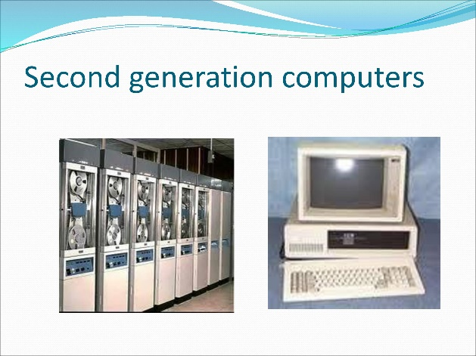

The 2nd generation computers were developed between 1956 and 1965.

2nd generation computers used **Transistors** instead of vacuum tubes. As Transistors are smaller than vacuum tubes computers became much smaller in size.

**The Third-generation computers (1965-1975)**

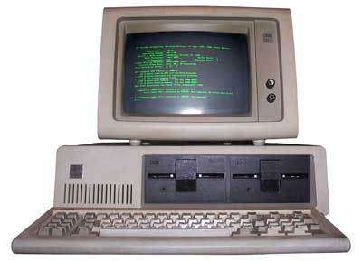

1956 to 1975 was the period of the third-generation computers.

3rd generation computers used **IC (Integrated Circuits).**

An integrated circuit is small as transistors but it can work as fast as thousands of them.

Integrated circuits made computers faster, Cheaper, and smaller than the 2nd generation computers.

**The fourth-generation computers**

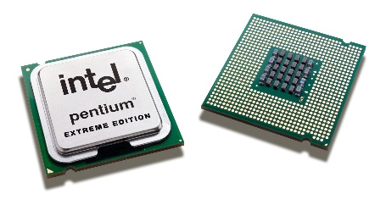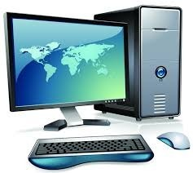

The computers developed since 1975 up to the present are called 4th generation computers.

4th generation computers used **microprocessors**. A microprocessor consists of a small silicon chip on which thousands of circuits are placed.

The fourth-Generation computers are smaller, portable, and cheap. They used less electricity and produce less heat.

**5th generation computers (The future)**

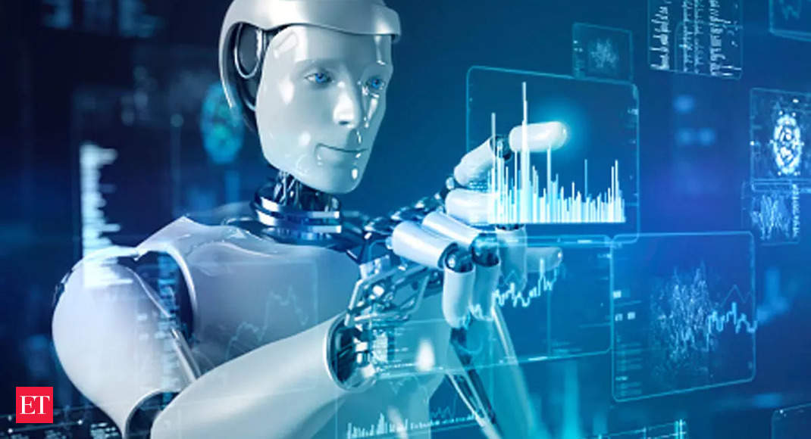

The 5th Generation computers are the most advanced. Scientists are trying to develop 5th-generation computers in a way that they can think on their own. This is called artificial intelligence (AI).

Robots work on this technology.

The following picture diagram explained how technology has the robustness to its premium.

